**Name:**Satyam Kumar Singh **Date:**29-03-2023

**College:**National Institute of Technology Patna

**Subject:**Assignment

Q.Explain:

a) Get b) Post c) Put d) Delete

-> **a) Get:** Get method is used to retrieve or get the information from the given server using a given URL. In REST CURD, it performs the read operation.

**Let’s try GET method** :

Let’s set up an HTML file that you can run locally on your browser. Create a file called get.html.Let’s look at the code :

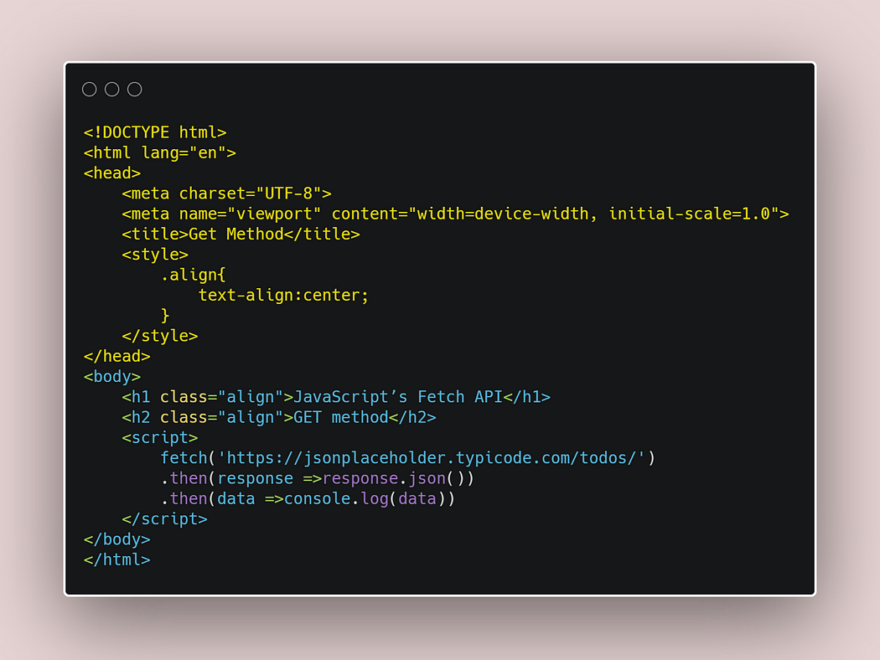

b) **Post:** Post is used for sending data to the server such as uploading a file or transferring some data or adding a new row to the back end table to any kind of web form. In a simple sentence, we can say that the post method is used for inserting new items in the backend server. In REST CRUD operation it performs the create operation.

**Let’s try the post method:**

Again create a post.html file that can run in your local browser. Let’s try the code:

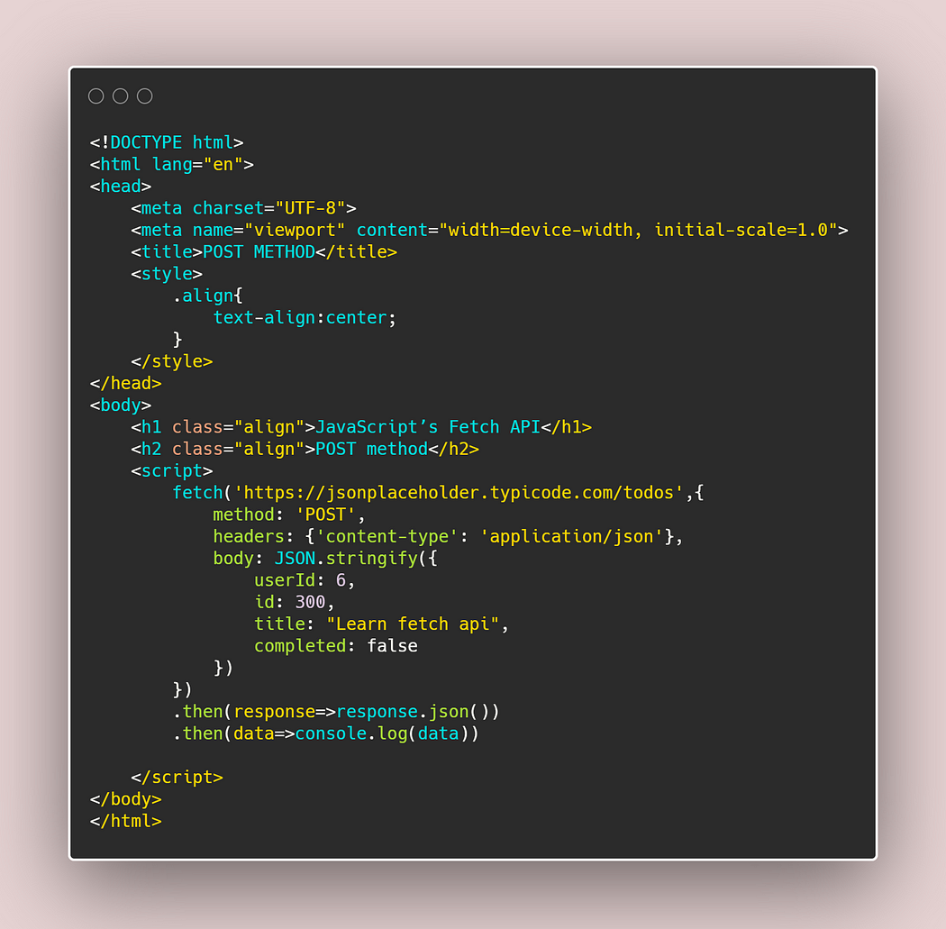

c) **Put:** The PUT method is most often used to update an existing resource.

let’s try to understand the PUT method mechanism:

In HTTP.PUT method, the resource is first identified by the URL and if it exists, then it is updated, otherwise, a new resource is created. In simply we can say that If the resource exists then update else create a new resource.

**Let’s try to understand the put method through the code**

Again create a put.html file. Let’s try this!!!

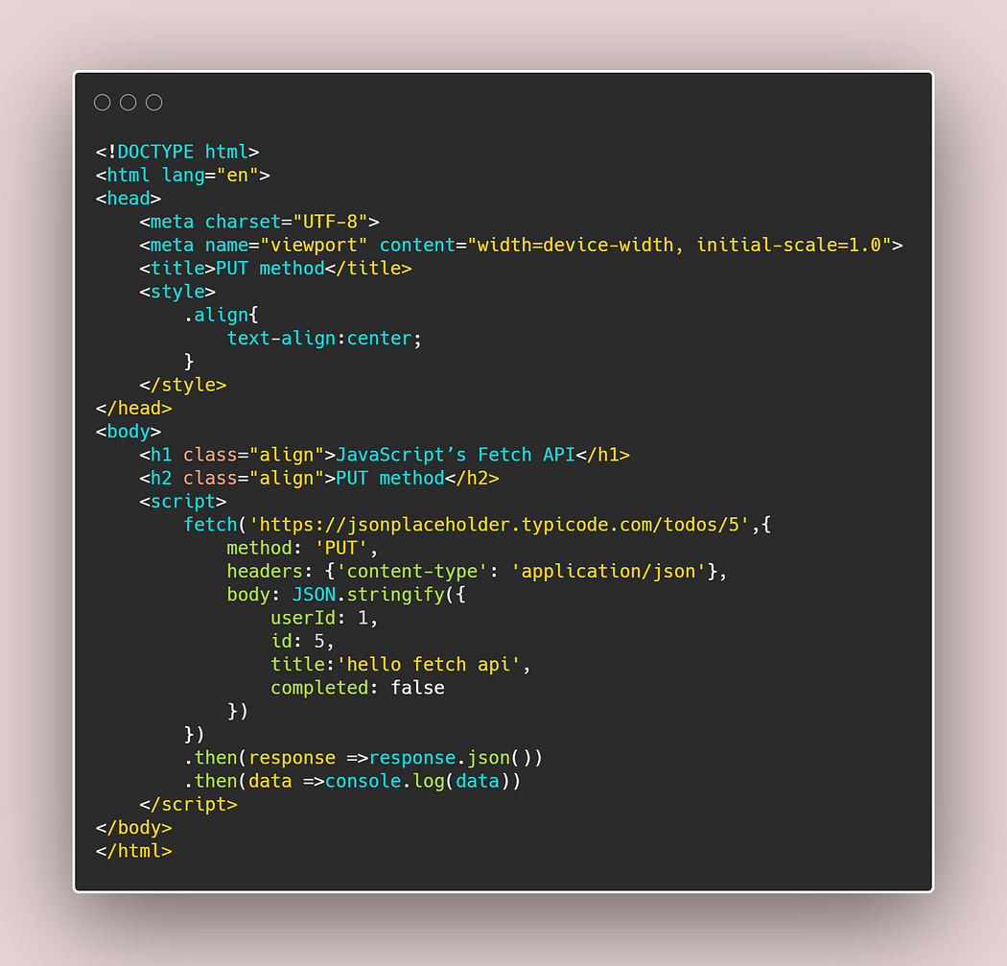

d) **Delete:** The DELETE method is used to delete a resource specified by its URI.

**Let’s try it!!!**

create a delete.html file in your local machine...

